DB XRechnungsgenerator - our solution for you to create XRechnungen.

General informationen about the generator
In this document you will find basic information and instructions for the XRechnungsgenerator.
In the following sections we would like to inform you about the terms of use, guide you through the generator and give you an overview of the mandatory and voluntary input fields.

You can reach the XRechnungsgenerator at http://xre.deutschebahn.com/

- Credentials of the XRechnungsgenerator
  - Username: db
  - Password: xrechnung

Terms of Use
After successful registration in the XInvoice Generator, your agreement to the Terms of Use is required. A link to the terms of use is available on this window.
Please read the terms of use and then make your decision. Unfortunately, you cannot use the XRechnungsgenerator without your consent.
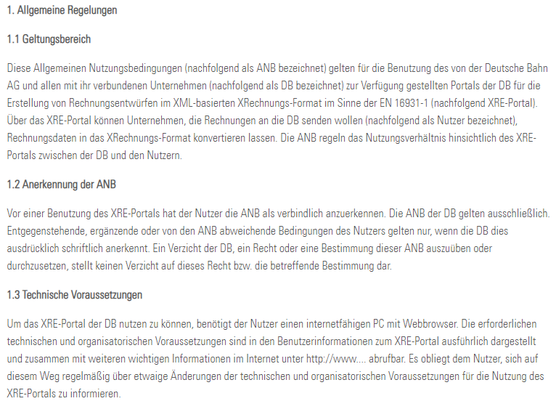

Overview of the input areas
The following illustration shows the overview of the input tabs in which there are input fields that must be filled out.
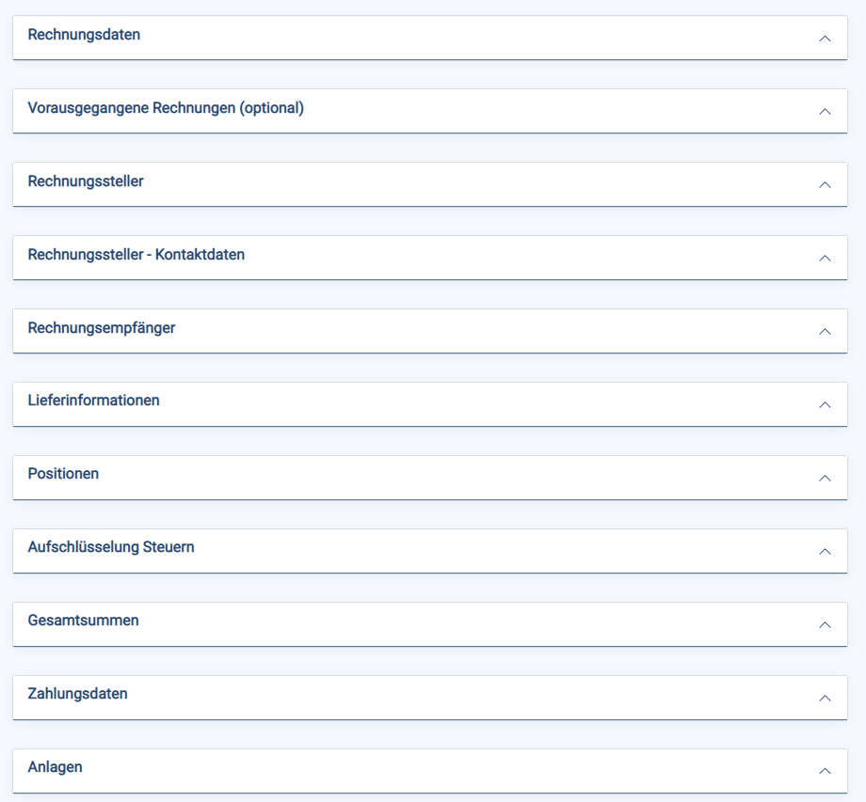

Meaning of the stars on the fields
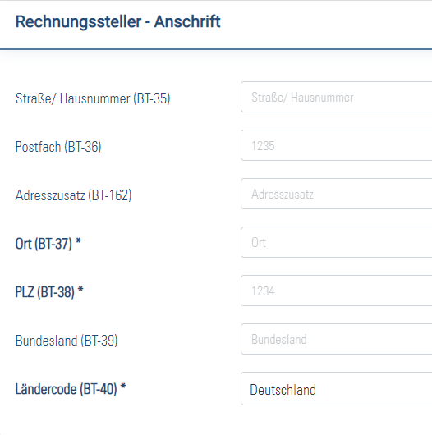
Das Fettgedruckte und die Sternkennung bedeuten, dass es ein Pflichtfeld ist
Keine Sternkennung bedeutet, dass es kein Pflichtfeld ist
The guide to the star symbols can be found at the bottom of the input mask.
Fields marked with * are mandatory fields for the creation of an XRechnung 2.0.0 compliant invoice. It is technically possible to create an invoice with fields that are not filled in, but the resulting invoice will not be compliant with the standard.
The validation of the generated XRechnung is carried out using KoSIT's XRechnung validation tool.
The BT- values (e.g. BT-1) refer to the corresponding elements in the XRechnung 2.0.0 standard.
The use of the browsers Google Chrome, Mozilla Firefox or Microsoft Edge is recommended for the use of this page. If Microsoft Internet Explorer is used, incorrect behaviour cannot be ruled out.
*Mandatory field: KoSIT and Deutsche Bahn AG, if not filled, a rejection takes place by the invoice monitor
** conditional required field: these fields are to be filled if certain fields were previously filled or if conditional compulsory fields were intentionally not filled (e.g.: If the field "Leistungszeitpunkt" (BT-72) has not been filled in, the field "Accounting period" (BT-73/74) must be filled in)
*** Important field: used by Deutsche Bahn AG to allocate the XRechnung

Instructions for creating the XRechnung using the XRechnungsgenerator
- Bold fields are mandatory and must be filled out, otherwise the XRechnung cannot be generated.
- If you want to interrupt filling out the invoice, you can click on "Zwischenspeichern" at the end of the form. You can upload this file again at any time and continue filling out the form.
  - The file is saved in a format that cannot be submitted to us as an invoice. It is for temporary storage only
- After you have completed the web form, please click on "Rechnung prüfen". You will recognise your correct invoice by the following message:

- If your invoice is not correct, you will receive an error message with a precise hint

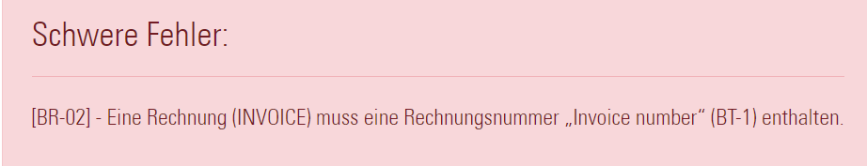

- You can then download a proper invoice in XInvoice format via the "Save XInvoice" button and visualise it in a PDF
  - The PDF is also a readable copy of the invoice for you

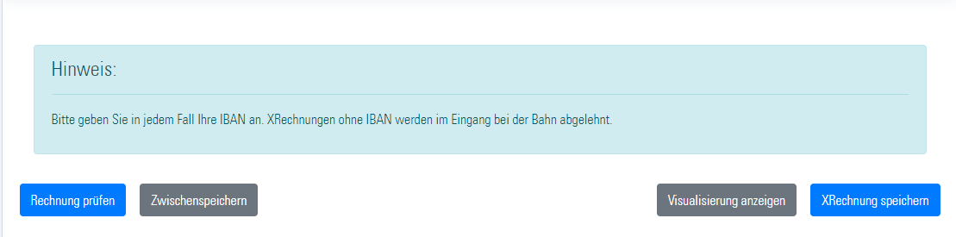

- Please send your XRechnung in the XML format to e-invoicing@deutschebahn.com
- After a few minutes you will receive an e-mail confirming the successful processing of your XRechnung.
- You can use already created and saved XRechnungen as a template for future invoices. You will find the upload field at the top of the website.

What to do if problems arise during creation of an XRechnung?
- The error codes provide information about which fields contain errors
- If the error codes do not help you, please check if your question is answered in the FAQs
- If you do not find an answer there either, please contact us at
SSCDE-KBH-Redaktion@deutschebahn.com.
In order for us to be able to help you, please make sure that your e-mail contains the following information:

  - Description the error in one sentence
  - Please add a screenshot of the error and the faulty XRechnung (you can save it on your PC by clicking the button "Zwischenspeichern")
  - Version of the XRechnungsgenerator (in the blue bar at the bottom right)

